|  |  |
| --- | --- |
|  | SSOM Faculty Promotion Packet Example |
|  | Academic Year 2022-2023 |
|  | HSC Faculty Administration |

* **Cover Sheet Example – Page 2**
* **Section 1: Department Letters – Page 3**
  + Chair Letter Example
  + Promotion Committee Example
* **Section 2: Candidate Curriculum Vitae – Page 6**
* **Section 3: Candidate Personal Statement – Page 7**
* **Section 4: Teaching Evaluations – Page 8**
  + Medical Student Evaluation Example
  + Resident/Fellow Evaluation Example
* **Section 5: Letters of Evaluation/Recommendation Requirements – Page 11**
  + ACRT Track
  + AET Track
  + ART Track
  + AST Track
  + CET Track
  + RT Track
  + Letter of Recommendation Example – **Page 13**



**Promotion and Tenure Cover Sheet 2022-2023**

**Candidate**: __________________________________

(First) (M.) (Last) (Credentials)

**Primary Department:**  _______________________________________

**Secondary Department(s), if applicable:** ______________________________________

**Present Faculty Status:** Full-time or Part-time

**Date of Initial Appointment at Loyola University: ___________________**

**Present Rank:** ___________________________ **Initial** **Date of Current Rank:** _________________

**Number of Years at Current Rank**: ______________________

**Is this an early promotion (less than 5 years in rank) ____________________**

* *If the number of years at the current rank is less than 5 years as of July 1, 2022, this is considered an* ***early promotion****. This requires the department letters, the faculty’s CV and personal statement to contain detail on how the faculty member demonstrated extraordinary effort for consideration for early promotion.*

**Present Tenure Status:**  Tenure-Track  Tenured Non-Tenure-Track

**Present Academic Track:**  AET  ART  AST ACRT  CET  Research Track

**Candidate Seeks:**

|  |  |  |
| --- | --- | --- |
|  | **Promotion, to be effective July 1, 2023 to the rank of:** | |
|  | Professor |
|  | Associate Professor |
|  | Rank of (Other): ___________________________  ☐ Clinical Professor (if Part-Time)  ☐ Clinical Associate Professor (if Part-Time) |
|  | **Tenure, with promotion (above), to be effective July 1, 2023** | |
|  | **Tenure only, to be effective July 1, 2023** | |

**Section 1:** Letter(s) from Department:

* Chair Letter (Mandatory for all submissions)
* If the faculty has a secondary/joint appointment, that chair of this department needs to provide a letter.

*The following categories are only for those departments that utilize this set-up for promotions:*

* Division Director Letter (Department of Medicine)
* Department Promotion Committee Letter

Not all departments will have a division director letter or a department promotion committee letter. However, all packets must include the Chair letter.

*\*Please note that a department promotion committee member cannot also author one of the candidate’s letter of evaluation/recommendation.*

Department Letter Examples follow on next page:

**Example of a Chair, Secondary/Joint Chair or Division Director Letter**

*If the candidate has a joint appointment, a separate letter is needed from Secondary Department Chair.

*A separate letter from the Division Director is needed for Department of Medicine faculty only.

On Letterhead

*Date (Must be dated within past 6 months)*

*To: Sam J. Marzo, MD*

*Dean and Chief Diversity Officer, Stritch School of Medicine*

*Re: Candidates Name, MD*

*Dear Dr. Marzo:*

*I write in support of the promotion of (Faculty Name) to the rank of (Associate Professor/ Professor) on the (Name of Track, i.e., ACRT, AET, ART, CET or RT) (if seeking tenure, put that THE detail here).*

*Dr. Candidate was recruited to Loyola in (YEAR). PROVIDE A DISCUSSION OF PAST EXPERIENCE, DETAIL ON TRAINING, I.E., DOCTORAL DEGREE, MEDICAL SCHOOL/RESIDENCY, FELLOWSHIP, ETC AND ANYTHING THAT STANDS OUT FROM THIS TIME. IF A PHYSICIAN, THEIR BOARD STATUS.*

*SPECIFIC DOCUMENTATION ON THE CANDIDATE PERFORMANCE FROM CRITEREA LISTED IN THE ACADEMIC GUIDELINES BASED ON THEIR ACADEMIC TRACK.   
  
The following are examples of what to include based on the faculty’s track, not all are applicable to every candidate:*

* ***Administrative duties******or participation on committees at the SSOM:*** *Hospital or university level, and offices held within the department, involvement in the recruiting process of residents and medical students will be considered as intramural service.*
* ***Teaching excellence:*** *Courses and lectures provided to medical students, residents, fellows, graduate students, etc., student counseling, student mentoring, tutoring and day-to-day teaching activities, and academic teaching rounds.*
* ***Administrative roles and teaching outside the medical center:*** *Extramural assignments such as invited presentations, selection to review panels, presentations at societal meetings, committee work on international, national or regional societies, performing manuscript reviews for journals, and being involved in legislative activities, i.e. state societies or regional activities, may also be considered.*
* ***Demonstrated Scholarly Activity/Grant Funding.*** *Publication of scholarly works, adoption of educational material in print or other media, syllabi, curricula, web-based training modules or courses, and/or technologies (e.g., simulation); development of educational methods, policy statements, and/or assessment tools; and/or popular dissemination of teaching expertise (e.g., blogs, webinars, Twitter Chats, etc.).* ***Grant Funding*** *– Current or grant funding within time at current rank.*
* ***Clinical Activity:*** *The candidate should have a sustained level of performance and reputation for clinical excellence at the SSOM and other service components of the LUHS.*

***For Early Promotions:*** *If this is an early promotion, acknowledgement of it being an early promotion and documentation of the extraordinary efforts the candidate has demonstrated during their tenure at LUC that supports the honor of early promotion.*

***Closing****: I support the promotion of Dr. CANDIDATE to the rank of Associate Professor/PROFESSOR with utmost enthusiasm. SUMMARY OF WHY THEY SUPPORT THIS PROMOTION.*

*Sincerely,*

***Original signature***

*Chair/Division Director Name, Title and Department*

**Example Department Committee Summary**

**Report of the Department of SPECIALITY - Promotion Review Committee**

CANDIDATE: ___________________________________________

DATE OF REVIEW: ___________________________________________

Following is a summary of the recommendation of the faculty review committee for Dr. CANDIDATE for promotion to the rank of Associate Professor/PROFESSOR in the Department of Name. We have reviewed Dr. CANDIDATE’S CV and the promotion criteria for this proposed rank and academic track. Our recommendation is based upon Dr. CANDIDATE’S teaching, research productivity, clinical program, national and international reputation and the service to the Department of SPECIALTY, the Stritch School of Medicine and Loyola University of Chicago.

Following is a summary of our findings (suggested topics):

* Time in Rank: 5 years
* Clinical Care Recognition:
* Peer Reviewed Published Research:
* External Funding:
* Other:
* Teaching and Service Recognition:
* Honors/ Awards:
* National and International Reputation:
* Editorial Contributor
* For Early Promotion – Acknowledgement that it is an early promotion and supporting criteria

Final recommendations of their findings and recommendation of promotion, including the vote count.

Members of the committee names.

***Original Signature***

Committee Chair Name

**Section 2:** **Candidate Curriculum Vitae**  
Following is the suggested format for the CV. A different style can be submitted, but must contain all of the requested information. A more detailed example is at: https://ssom.luc.edu/cart/

**Curriculum Vitae Format Example**

**General Information**

Date Prepared: Must have a current date

Name: Full name, Degree

Office Address

Home Address

Work e-mail:

**Education:**

Full name of all higher educational institutions attended, included postdoctoral training, internships, residencies, clinical and research fellowships

Month/Years attended

For graduate degrees, note field or discipline.

**For the next categories, please make sure to include name of academic institution, title and month/years (list only those positions that are related to your professional field)**

* Academic Appointments
* Hospital or Affiliated Institution Appointments
* Other Professional Positions and Major Visiting Appointments
* Hospital and Health Care Organization Service Responsibilities and Major Administrative Responsibilities
* Major Committee Assignments
* Professional Societies and Society Role (e.g., member, officer, committee assignment)
* Community Service Related to Professional Work
* Editorial Boards
* Awards and Honors

**PART II: Scholarly Activities, Research, Teaching and Clinical Contributions**

* Grants – Detailed information required – dates, role, funding information, title, brief description of research;
* Current Research: Activities other than those mentioned above (bench research, clinical trials, outcome studies, efficacy studies as applicable) – same detailed information required;
* Report of Teaching: Local contributions, graduate medical course, local invited teaching presentations, e.g., seminars, grand rounds, continuing medical education course, advisory and supervisory responsibilities in clinical or laboratory setting (for medical or graduate students, resident or fellows), teaching leadership role in department/affiliated Institution/Medical School;
* Names of Advisees or Trainees: Years in position under your supervision, and current position. List only those trainees on whose careers you have made a significant impact;
* Invited Presentations (e.g., visiting professorship, invited lecture, plenary presentation, seminar);
* Professional and Educational Leadership Roles: e.g., program chair for professional society annual meeting or member of steering committees;
* Administrative Responsibilities at home institution and beyond LUC;
* Description of teaching award(s) received;
* Major curriculum offerings, teaching cases or innovative educational programs developed;
* Report of Clinical Activities.

**Part III: Bibliography**

Number references consecutively in order in which they were published (*oldest first*)

**Section 3:** Candidate’s Personal Statement

* Must be in the form of a narrative; not an outline.
* The narrative provides detail that supports the candidate meeting all of the criteria listed on their academic track guidelines to support a promotion.

**Example Personal Statement**

DATE

Personal Statement for NAME, MD

It is an honor to be proposed for promotion to RANK of SPECIALITY at Loyola University Medical Center. FOLLOWING IS AN OVERVIEW OF MY CONTRIBUTIONS TO MY DEPARTMENT AND LOYOLA UNIVERSITY CHICAGO DURING MY TENURE AT LUC:

SPECIFIC DOCUMENTATION ON THE CANDIDATE PERFORMANCE FROM CRITEREA LISTED IN THE ACADEMIC GUIDELINES BASED ON THEIR ACADEMIC TRACK. The following is for the CET Track:

* **Clinical Activity:** The candidate should have a sustained level of performance and reputation for clinical excellence at the SSOM and other service components of the LUHS.
* **Administrative duties** **or participation on committees at the SSOM:** Hospital or university level, and offices held within the department, involvement in the recruiting process of residents and medical students will be considered as intramural service.
* **Teaching excellence:** Courses and lectures provided to medical students, residents, fellows, graduate students, etc., student counseling, student mentoring, tutoring and day-to-day teaching activities, and academic teaching rounds.
* **Administrative roles and teaching outside the medical center:** Extramural assignments such as invited presentations, selection to review panels, presentations at societal meetings, committee work on international, national or regional societies, performing manuscript reviews for journals, and being involved in legislative activities, i.e. state societies or regional activities, may also be considered.
* **Demonstrated Scholarly Activity:** Publication of scholarly works, adoption of educational material in print or other media, syllabi, curricula, web-based training modules or courses, and/or technologies (e.g., simulation); development of educational methods, policy statements, and/or assessment tools; and/or popular dissemination of teaching expertise (e.g., blogs, webinars, Twitter Chats, etc.).
* **Grant Funding** – Current or grant funding within time at current rank.

**For Early Promotions:** If this is an early promotion, acknowledgement of it being an early promotion and Documentation of the extraordinary efforts the candidate has demonstrated during their tenure at LUC that supports the honor of early promotion.

Closing Remarks: Summary of their accomplishments, etc.

***Original Signature***

CANDIDATES NAME

Section 4: **Teaching Evaluations**

* Required for all years at current rank, separated by academic year;
* Must be Anonymous Evaluations;
* Unique to the Candidate – does not include other instructors names;
* Optimally, the evaluations will be formatted to a yearly summary report for each academic year by each type of trainee group.
* Evaluations are from the following LUC/SSOM categories of trainees:
  + **Medical Student Evaluations**  – Ask your department’s SSOM Clerkship Coordinator. A medical student’s faculty specific comments and scores are automatically pulled into the faculty member’s FIS, annual summary, and in ranked order (highest scores first and color coded).  These are listed annually and could be copied and pasted into a document for submission.
  + **Graduate Student Evaluations** – These are dependent upon the assigned department administering and collecting them. SSOM currently does not collect these in FIS. Some departments may request them, but they aren’t currently formally collected. For example, the department of Bioethics collects evaluations for their own graduate student teaching sessions. This said, I believe the University has an online course evaluation system but it isn't universally used by all graduate programs.
  + **Resident Evaluations** – Ask your department’s Residency Coordinator to run a report in New Innovations
  + **Fellows Evaluations** - Ask your department’s Residency Coordinator to run a report in New Innovations
  + **Grand Rounds Evaluations** - These ae collected by departments and part of the CME requirements for Grand Rounds. For assistance, please contact Mary Jurasas, Administrative Director of Continuing Medical Education (CME), at [mjurasas@luc.edu](mailto:mjurasas@luc.edu).
  + **Lecture Evaluations and Simulation Lab Evaluations** - If lectures or simulation events incorporate SSOM students, they would be captured by SSOM and imported into FIS, but if resident activities, it would be dependent upon the department, GME typically captures these resident/fellow evaluations of teaching faculty. Some departments do collect evaluations on each presentation.
* If the faculty member has been at LUC for less than two years, teaching evaluations should be obtained from former institutions.
* ***Please note that teaching evaluations are required for all academic tracks.***
* ***For CET track, teaching evaluations are mandatory as teaching is a major component of this academic track.***

**Evaluation Examples**

* One evaluation summary report should be provided for each academic year the faculty has been teaching. *For example, if the faculty taught residents every year since their last promotion, a total of five residency summary evaluation reports would be provided broken down by the following dates:*

*July 2016 to June 2017, July 2017 to June 2018,*

*July 2018 to June 2019, July 2019 to June 2020,*

*July 2020 to June 2021*

* Both scores and comments from evaluators are needed.
* Evaluations reports are the original reports; no cutting and pasting to a new document.

**Medical Student Evaluation Example: (*Medical student evaluations can be obtained from your department’s SSOM Clerkship Coordinator)***

 **One evaluation summary per academic year**

**Dr. Candidate’s Name**

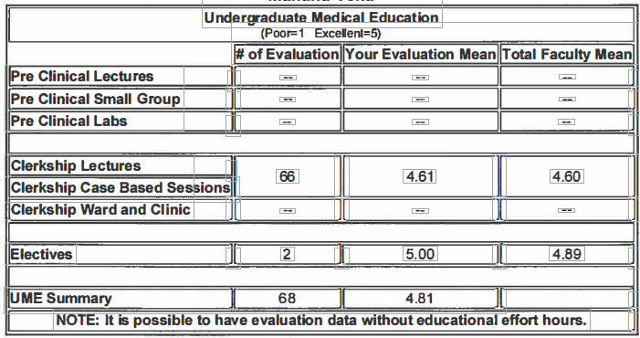

**Medical Student Comments:**

**Please follow the case discussion for the next lecture you give.**

**Excellent! Enthusiastic and knowledgeable teacher. Challenged us to go beyond our automatic answer of protoco1 treatments**

**Phenomenal Teacher. He wanted to make sure that we actually understood the topic.**

**Very knowledgeable.**

**Resident/Fellowship Evaluation Summary Example:  *(obtained from department educational coordinators – report in New Innovations):***

**Department of Specialty**

**Residents Evaluations of Attending**

**One evaluation summary per academic year**

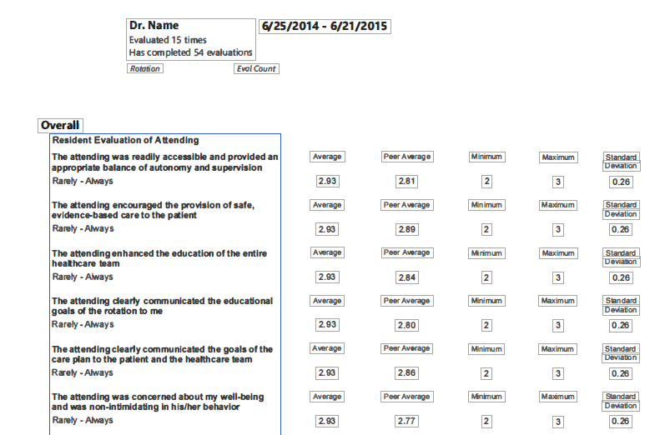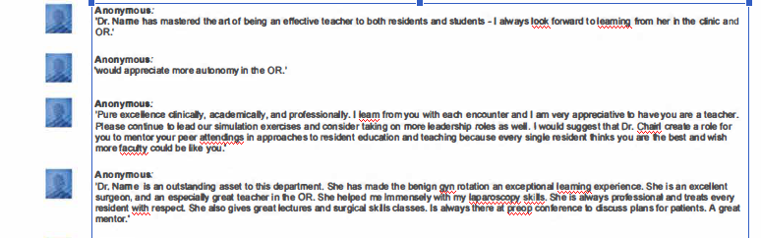

**Dr. Candidate – 07/01/2015 – 06/30/2014**

Section 5: Letters of Evaluation/Recommendation:

* Authors of letters must be of the same rank the faculty is going up to for promotion or above the candidate’s proposed promotion rank;
* Letters must be on letterhead;
* Author’s current rank and discipline/specialty referenced in letter or under signature;
* Letters are addressed to the department Chair;
* Letters are dated within 6 months of promotion packet submission;
* Author cannot be a former mentor or advisor;
* Author must be an academician in the candidate’s discipline or specialty area;
* Author cannot be a department promotion committee member, unless they recuse themselves from their own internal department’s promotion committee’s deliberations. This will need to be noted in the letter of recommendation.
* Number of recommendation letters are based on academic track, as listed below.

**CET Track**

***Promotion to Associate Professor***

*New Guidelines – CET Track -*

4 letters total - Promotion to the Associate Professor level on the CET will require 1 external letter of recommendation/evaluation and 3 internal letters of evaluation. All letters must come from referees at the academic rank of associate professor or its equivalent in the candidate’s discipline or specialty area and must exclude letters from the candidate’s former mentors or advisors.

***Promotion to Professor***

*New Guidelines – CET Track*

4 letters total. Promotion to the professor level on the CET will require 3 external letters of recommendation/evaluation and 1 internal letter of recommendation/evaluation. All letters must come from referees at the academic rank of professor or its equivalent in the candidate’s discipline or specialty area and must exclude letters from the candidate’s former mentors or advisors.

**ART Track**

***Promotion to Associate Professor with/without Tenure***

*New Guidelines – ART Track – Promotion to Associate Professor with Tenure*

The department chair will obtain letters from at least 4 to 6 non-Loyola researchers, of whom at least four were not the primary mentors during the candidate’s training as a PhD student or post-doctoral fellow, or current collaborators. The letters will be from prominent individuals in the candidate’s field of expertise, who can assess the productivity, quality, and goals of the candidate’s research efforts. The chair will request that letter-writers provide a short CV, such as an NIH bio sketch. If not clarified in the recommendation letter, the chair will specify in their letter whether the recommender trained the candidate.

***Promotion to Professor with/without Tenure***

*New Guidelines – ART Track*

The department chair will obtain letters from at least 4 to 6 non-Loyola researchers, of whom at least four were not the primary mentors during the candidate’s training as PhD student or post-doctoral fellow, or current collaborators. The letters will be from prominent individuals in the candidate’s field of expertise, who can assess the productivity, quality, and goals of the candidate’s research efforts. The chair will request that letter-writers provide a short CV, such as an NIH bio sketch. If not clarified in the recommendation letter, the chair will specify in their letter whether the recommender trained the candidate.

**AET Track**

***Promotion to Associate Professor without Tenure***

*New Guidelines – AET Track*

2 letters of evaluation from non-Loyola faculty of appropriate rank;

1 letter of evaluation from a Loyola faculty of appropriate rank.

***Promotion to Professor without Tenure***

*New Guidelines – AET Track*

2 letters of evaluation from non-Loyola faculty of appropriate rank;

1 letter of evaluation from a Loyola faculty of appropriate rank.

**New Track: AST Track**

***Promotion to Associate Professor with Tenure***

*New Guidelines – AST Track*

2 letters of evaluation from non-Loyola faculty of appropriate rank;

1 letter of evaluation from a Loyola faculty of appropriate rank.

***Promotion to Professor with Tenure***

*New Guidelines – AST Track*

2 letters of evaluation from non-Loyola faculty of appropriate rank;

1 letter of evaluation from a Loyola faculty of appropriate rank.

**ACRT Track**

***Promotion to Associate Professor with/without Tenure***

*New Guidelines – ACRT Track*

2 letters from two non-Loyola academicians (other than prior mentors or advisors) in the candidate’s discipline or specialty area will be solicited. These letters should include an appraisal of the quality, contribution and goals of the candidate’s academic career. One or more additional letters will be obtained from outside or within the Loyola community. All letters must come from referees at the academic rank of associate professor or its equivalent and must exclude letters from the candidate’s former mentors or advisors.

***Promotion to Professor with/without Tenure***

*New Guidelines – ACRT Track*

In either the ACRT tenure or non-tenure track, promotion to professor and/or the granting of tenure will be evaluated using the same criteria as detailed for associate professor, with letters from non-Loyola researchers evaluating the national and international reputation of the candidate. Four letters of recommendation, three external, are required for promotion to full professor and must exclude letters from the candidate’s former mentors or advisors.

**RT Track**

***Promotion to Associate Professor and Professor***

*Current and New Guidelines*

4 to 5 letters non-Loyola Researchers with at least 4 not primary mentors during training or current collaborator.

**Example Letter of Recommendation** Physician’s Letterhead

Date (must be written within past 6 months)

Address Letter to:

Chairman of Department

Department Name

Loyola University Medical Center

Dear Dr. Chairman Name:

It is my pleasure to write this letter of recommendation for Dr. NAME for the appointment of _____________________________ in the Department of _____________.

* Please provide a summary of your professional qualifications as the letter writer.
* Applicant Information: A summary of the following qualifications, as applicable to the applicant, needs to be provided. Following are examples of what to address:
* Length of time you have known the letter writer.
* Known administrative activities or participation on committees either at local, regional, national or international organizations: professional supervision, participation in student and resident training-centered activities, extramural assignments such as invited presentations, selection to review panels, presentations at societal meetings, committee work on international, national or regional societies, performing manuscript reviews for journals, and being involved in legislative activities, i.e. state societies or regional activities.
* Teaching - Courses taught to trainees, lectures given, student counseling, student mentoring, tutoring and day-to-day teaching activities, and academic teaching rounds.
* Demonstrated Scholarly Activity - publication of scholarly work in peer-reviewed journals, or invited manuscripts, book chapters, review papers, abstracts given, exhibits presented at national organization meetings or invited manuscripts, development and local adoption of educational material in print or other media, syllabi, curricula, web-based training modules or courses, and/or technologies (e.g., simulation); development of educational methods, policy statements, and/or assessment tools’ publication of chapters and reviews within textbooks; development of educational material in print or other media with local.
* Grant Funding/Research – list any known grant funding or research of applicant.
* Clinical Activity - Any reputation for clinical excellence or other clinical service components.

I support the appointment of Dr. NAME with strong enthusiasm.

Sincerely,

Original Signature

Author Name and Credentials

Author Rank

Institution/Organization